ss2581
Abstract
We all know that the time on a clock doesn't always match how we feel. A video can feel really short or drag on for ages depending on what's happening in it. In this project, I wanted to see if a computer model could predict how long a video feels to a person just by looking at the images and listening to the sound. This builds on a study by Roseboom et al. (2019), but I’ve added an audio part using OpenL3 to see if sound makes the prediction better.
An online experiment was conducted using jsPsych, where 35 participants watched short travel video clips (10–25 seconds) and marked how long they thought each one lasted. A deep learning pipeline was built to extract visual features from each frame using AlexNet and audio features using OpenL3. The amount of change between frames was measured at each timestep, and a tick-counting accumulator mechanism was used to estimate the duration of time they thought had passed, which was then converted to seconds using a simple linear calibration. A late-fusion approach combined the visual and audio predictions into one final estimate per clip. Model predictions were compared against human responses using Pearson correlation and mean absolute error (MAE).
Before the main experiment, the visual model was validated against a dataset provided by the supervising researcher (Dr Warrick Roseboom), containing over 4000 trials from 55 participants across 33 video clips. The visual model achieved a Pearson correlation of r = .847 with human estimates, outperforming three existing comparison models from Roseboom et al. (2019), including the Gaze model (r = .743) and the Still model (r = .630), and approaching the theoretical ceiling set by objective duration (r = .862).
The results show that our brains might track time by counting how much sensory information changes around us. This is important because it helps us understand how human memory works and could help make AI feel more "human" when it interacts with us.

Introduction
Motivation
Time is something everyone experiences, but nobody experiences it the same way. Think about the last time you were really into something, maybe a movie, a game, or a hanging out with friends, and you looked up to realize an hour had passed without you even noticing. Or the opposite: sitting in a waiting room where five minutes felt like twenty. This gap between how long something actually lasts and how long it feels like it lasts is called subjective time perception, and it happens to everyone, all the time.
This might seem like just a small quirk of how our brains work, but it actually matters a lot in the real world. In movies and YouTube videos, the pacing changes how bored or excited a viewer gets. In app design, if a loading screen feels too long, people get frustrated, even if it only took a few seconds. Even in hospitals, patients who are in pain often feel like they’ve been waiting much longer than they actually have. If we could understand what causes this and use a computer to predict it, it would be really useful for all these different areas.
The main question I’m looking at is pretty simple: can a computer watch a video and guess how long a person will think it lasted? I’m not talking about the actual time; a computer can tell you that easily. I’m talking about the "felt" time, which is the number of seconds a person would type in if you asked them right after the video ended. This is a much tougher problem because it means the computer has to try to understand how the human brain builds its sense of time based on what it sees and hears.

Background

For a huge part of the twentieth century, psychologists tried to explain how we perceive time by using what they called an "internal clock" model. The basic starting point, found in scalar expectancy theory, is the idea that the brain has a built-in pacemaker that constantly sends out regular pulses. These pulses get picked up and stored by a counter, and whenever you need to decide how long an event lasted, you just check how many pulses were recorded. The logic is simple: the more pulses you count, the longer you think the time was. This model was the go-to theory for decades because it is straightforward and it actually makes pretty accurate predictions when you test people in very controlled, quiet laboratory settings. (Buhusi & Meck, 2005).
However, the internal clock model has one really big weakness: it treats time perception like something that happens totally on its own, regardless of what you are actually doing or seeing. In the real world, our sense of time changes depending on the context. Because of this, researchers tried to improve the model by adding an "attentional gate." This is basically a mechanism that controls how many of those pulses actually reach the counter based on where you are looking. If you are focusing really hard on the time, like staring at a clock, the gate stays wide open, more pulses get through, and time feels like it's dragging. But if you are focused on something fun or engaging, the gate closes a bit, fewer pulses get through, and time seems to fly by. While this explains why boring tasks feel long and fun ones feel short, it still relies on that same idea of a hidden clock ticking away in the background.
A completely different family of theories eventually came out of memory research. These researchers proposed that the brain might not use a clock at all. Instead, they think the brain estimates time by looking back and seeing how many distinct events or changes happened during that period. If a lot of different things happened and your brain saved them as memories, the time feels long. If almost nothing happened, it feels short. This is known as the "contextual-change hypothesis," and it has led to more modern models based on events and changes. A famous example of this is the "holiday paradox." When you are on a busy, exciting vacation, the time feels like it's going fast because you’re too busy to count it. But once you get home and look back, the trip feels like it lasted a long time because you have so many new, distinct memories. For this project, these change-based models are the most important because they give us a testable rule: more change in a video should lead to a longer estimate of time.
This specific prediction has been tested a lot in both vision and hearing. In the visual world, experiments that change how complex a scene is, how fast things move, or how often the image changes have consistently found that more visual activity makes people think a video is longer. For example, some researchers showed that a light flickering quickly feels like it lasts longer than a steady light, even if the actual time is exactly the same. We see the same thing in hearing; sounds with more layers, more frequent noises, and more information tend to feel longer than simple, quiet sounds (Teki et al., 2012). What is really important is that these visual and auditory effects seem to happen mostly independently of each other. This means that both sight and sound contribute to our overall sense of time, so a computer model that combines both should technically work better than a model that only uses one.

State of the Art

The most important research for this project is the work by Roseboom et al. (2019), who created a computer model for time perception using a deep convolutional neural network. Their big idea was that you don’t actually need to build a specific "clock" inside a computer. Instead, you can take a network that is already trained to recognize objects, specifically AlexNet, which learned from over a million images, and simply track how much its internal "view" changes from one video frame to the next. When the network sees a new frame that looks very different from the one before it, the model marks that as a major event. It counts these events over the course of a video and uses that total number to guess how long the video lasted.
To get technical for a moment, the model looked at every frame of a video (sampled at 30 frames per second) and pulled out a 4096-dimensional "feature vector" from a specific part of AlexNet called the fc7 layer. By calculating the Euclidean distance between consecutive vectors, the model got a score for how much things changed frame-by-frame. If the change was big enough to pass a certain threshold, a counter recorded it as a "salient event." At the end of the clip, that total count was converted into seconds using a simple math formula (linear regression) based on human data.
The results were really impressive. They tested the model on 4,251 trials where 55 people watched videos and guessed their duration. The model’s guesses were very similar to the human ones. The "Gaze" version of the model, which focused on the parts of the screen where humans actually look, did the best (r = .743 with human estimates, RMSE = 10.71 s). Even a simpler version that looked at the whole frame - the “Still” model hit r = .630 (RMSE = 11.99 s). A “Shuffled” control model that used temporally scrambled features served as the baseline and achieved r = .677 (RMSE = 11.79 s). This was important because it proved that a network trained just to identify pictures, with no actual knowledge of time, could still act like a human brain when judging duration. It even made the same mistakes humans do, like underestimating long clips.
Later, Sherman et al. (2022) took this further by using fMRI to scan people’s brain activities while they watched these videos. They found that the same "change-counting" logic could be seen in the activity of the human visual cortex. Interestingly, this didn't happen in the auditory or touch-related parts of the brain in their study, suggesting that visual changes are a huge driver of our sense of time. Together, Roseboom et al. (2019) and Sherman et al. (2022) provide strong evidence that counting up perceptual changes is a very likely way the human brain keeps track of time.
However, both of these studies only looked at vision. They didn't include any sound, even though most things we experience in the real world involve both sight and sound. In the 2019 study, the videos were actually shown to people without any audio at all. This leaves a big question: does adding sound help a model predict time better, and if so, how much of a difference does it make?
To handle the sound part, this project uses OpenL3 (Arandjelovic & Zisserman, 2017). This is a deep learning model trained to figure out if a sound and a video clip belong together. Because it was trained on such a huge variety of natural videos, it is really good at picking up on the kinds of auditory changes that might affect our sense of time. It’s a much better choice than other models like VGGish, which is mostly focused on music and doesn't give us as much detailed information.
In this project, I combined the two models using a late-fusion approach. This just means the visual model and the audio model each make their own independent guess, and then those two guesses are merged together. This is similar to how the human brain works, often called Bayesian cue integration (Hartcher-O'Brien et al., 2014; Jagini, 2021), where the brain combines information from different senses based on which one it trusts more at that moment. This approach is a great starting point because it’s easy to understand, and it lets me see exactly how much the visual and audio parts are helping before I mix them together. For a bigger look at all the different ways researchers try to model time, you can check out Basgol et al. (2020).
Problem Statement

Even though Roseboom et al. (2019) and other researchers have made a lot of progress, there is still a big gap in what we know: no one has actually tried to combine deep learning for visual changes with deep learning for audio changes to predict how long a person thinks an audiovisual video lasts. My study is designed to fill that gap with five main goals:
Goal 1: I want to get a "behavioral baseline" by having real people watch travel videos with sound and guess their duration. I'm doing this through an online experiment using jsPsych.
Goal 2: I need to build and test a visual model using AlexNet (specifically the fc7 layer). I’ll check it against a big dataset from Dr. Warrick Roseboom to see how it compares to the three older models from the 2019 study.
Goal 3: I will build an audio-only model using OpenL3. This model will be calibrated using the human guesses I collect in my own experiment.
Goal 4: I’ll combine the visual and audio models using late fusion. This will let me create "blind" predictions for the travel clips, which I can then compare directly to what humans actually thought.
Goal 5: Finally, I want to see if combining sight and sound actually makes the model more accurate than just using sight alone. This will tell us a lot about how time perception theories work in the real world and how we can better model it for AI and media.
Based on these goals, I have two main hypotheses:
Hypothesis 1: When a video has more visual and auditory changes happening, human participants will estimate that it lasted longer.
Hypothesis 2: The predictions from my combined model, using AlexNet for vision and OpenL3 for audio merged together, will show a strong correlation with human guesses. I expect this multimodal model to be more accurate than the version that only looks at visual data.

Method

Participants

My target sample size for this experiment was somewhere between 50 and 100 participants, which is what I originally outlined in my ethics application. To find people, I reached out for volunteers through university Discord servers, various social media posts, and by just asking my personal contacts.
I had a few basic rules for who could take part: participants had to be at least 18 years old, have normal (or corrected-to-normal) vision and hearing, and importantly, have no history of photosensitive epilepsy or any sensitivity to flashing lights. I also had to require everyone to complete the study on a desktop or laptop computer. This is because mobile phone browsers can be really unreliable when it comes to playing the video files exactly how I needed them to for the experiment.
Before anyone actually started the test, they had to read a participant information sheet and give their informed consent by simply checking a box on the screen. I made sure to let them know that they could withdraw from the study at any time just by closing their browser window with no need to give a reason, and that no personal information would be stored. The whole study was given official ethical approval by the University of Sussex Faculty Research Ethics Committee (F-REC Science, Engineering and Technology; reference: SEMSET 1393).

Stimuli

For the experiment, I put together a set of 36 unique video clips from YouTube, specifically looking for natural, first-person perspective (POV) travel footage. I made sure to pick a wide variety of places, like busy city streets, outdoor landscapes, and indoor spaces. This ensured there was a good mix of simple and complex sights and sounds across the whole set. Every clip was trimmed down to last between 10 and 25 seconds, and I standardized the audio volume to -20 dB RMS so that nothing was unexpectedly loud.
I then took each of those 36 clips and created three different versions, giving me 108 total files for the study:
- Video + Audio - the clip played with both picture and sound.
- Video only - the clip played with the audio track removed (silent)
- Audio only - only the soundtrack played, with no visual content shown
This three-condition setup is really important because it lets me directly compare how people judge the exact same event depending on whether they can see it, hear it, or both. Finally, to make sure everything played smoothly without crashing during the session, I hosted all these files on Cloudflare R2 cloud storage. This allowed the videos to stream directly to the participants through the experiment interface while they took the test.
Design

For the layout of the study, a mixed design was used. The type of media a person experienced, whether it was video with audio, video-only, or audio-only, was a "between-participants" variable. This basically means that a participant only ever saw a specific clip in one format. They never saw the exact same clip twice in different conditions, which kept them from just remembering their previous guess. However, the 15 clips they watched during the session were a "within-participants" variable, because each participant made duration estimates for all 15 clips they were assigned.
Each session consisted of exactly 15 clips: 5 from the video+audio condition, 5 from the video-only condition, and 5 from the audio-only condition. The way I picked which specific clips someone watched was actually done dynamically using a counter stored in a Cloudflare D1 database. Since I had 108 total clip-condition combinations, the database kept a running tally of how many times each one had been judged. Whenever a new participant logged on, the system automatically looked at the database and picked the least-seen clips from each category. This adaptive assignment ensured that data was collected roughly evenly across all 108 combinations over the course of the experiment, without having to manually assign people to strict groups beforehand.
As mentioned before, the system was programmed so that no participant would ever see the same base clip in more than one format. Once the 15 clips were picked for a session, they were shuffled into a completely random order that was uniquely generated for every single person.
The main thing I was measuring was each participant's duration estimate in seconds for each clip. The whole point of having the three different conditions is to see if people perceive time differently depending on whether they are only seeing something, only hearing something, or experiencing both at the same time. They also provide the ground truth data for calibrating and evaluating the unimodal and multimodal computational models.

Procedure

To build the experiment, I used jsPsych and deployed it using Vercel for the frontend. The domain and backend infrastructure were managed through Cloudflare. Cloudflare Workers took care of the API logic, Cloudflare R2 stored the video and audio stimuli and streamed them directly to participant’s browser, and participant responses were stored anonymously in a Cloudflare D1 database, tagged only with a randomly generated session ID created locally when the participant began the study.
Participants accessed the experiment through a URL shared during recruitment. When they opened the link, they were presented with the participant information sheet. After reading it, they confirmed their consent by ticking a checkbox and clicking continue. The experiment then began immediately after the media files were pulled from the cloud service.
Each trial followed the same structure. A loading circle appeared while the next clip was being prepared, after which the clip played automatically in full. As soon as the clip finished, a response screen appeared with the question: "How long did the previous clip last?" Participants responded by moving a slider to indicate their estimate. The slider ranged from 0 to 60 seconds. Once the participant had moved the slider to their chosen value, they clicked a button to confirm their response and move on to the next clip. No feedback was given about whether the estimate was accurate.
The 15 clips were always presented in a randomly shuffled order, independently randomised for each participant. Upon completing all 15 trials, participants saw a short debrief screen explaining that the study was about how humans perceive time in different media, and thanking them for participating.

Preprocessing
Before feature extraction, all video clips were passed through a standardised preprocessing pipeline implemented in Python using moviepy, librosa, and OpenCV.
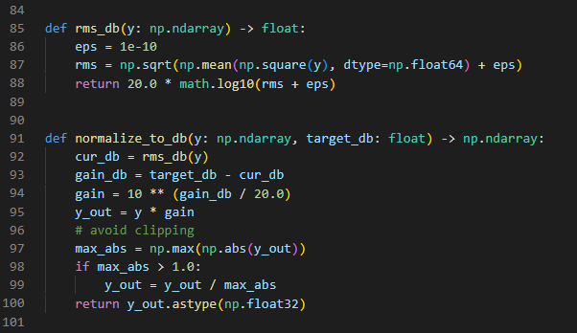
Audio normalisation. Audio was extracted from each raw video file and converted to 48,000 Hz mono WAV format. Then, I adjusted the volume so that every single clip sat at a target level of −20 dB RMS using a gain-based procedure. The current RMS level of each clip was calculated, the gain required to reach the target was computed and applied to the full signal, and the output was checked for clipping. If the audio got too loud and started to distort (going over ±1.0), I scaled it back down proportionately to keep everything sounding clear. I made sure not to cut out any silent parts, so the exact length of the original clip stayed the same. This normalisation step ensures that differences in original recording volume do not affect the downstream audio feature extraction. This way, the OpenL3 model is actually analyzing the genuine sounds happening in the clip, rather than just reacting to how loud the camera's microphone happened to be.

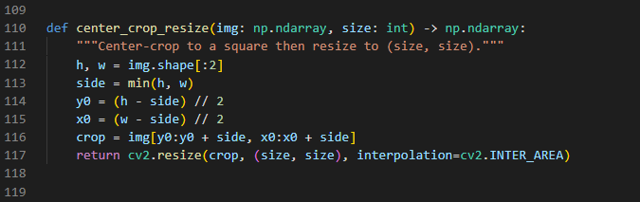
Frame extraction. For the visual pipeline, each processed video was decoded frame by frame using OpenCV. Frames were sampled at a fixed rate of 30 frames per second using a uniform stride. Because AlexNet needs perfectly square pictures, each sampled frame was centre-cropped to a square by taking the shorter of the height and width as the crop dimension, then resized to 224 × 224 pixels. This preserves the aspect ratio of the original footage without distortion. Frames were saved as JPEG files alongside a frame_times.npy array recording the timestamp of each frame in seconds, which is used later to align visual and audio features in time.

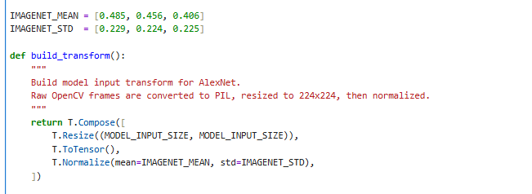
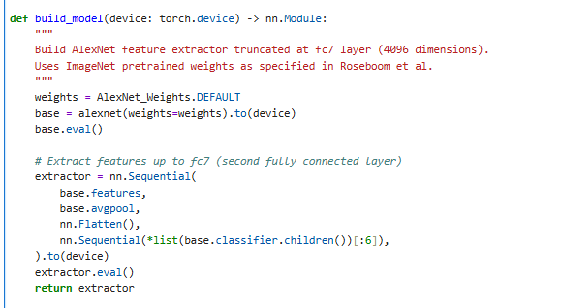
Visual feature extraction. For the visual feature extraction part, I started by loading up all the saved JPEG frames and putting them through a quick preprocessing transform feeding them into the AlexNet model. First, the code double-checks that each picture is exactly 224 by 224 pixels. Then, the images were converted into a tensor, and normalised using the ImageNet training set statistics (mean = [0.485, 0.456, 0.406], SD = [0.229, 0.224, 0.225] across the three RGB channels). Frames were processed in batches of 64 on GPU to make efficient use of available hardware. Feature vectors were extracted from the fc7 layer of AlexNet, giving em a 4096-dimensional representation per frame.

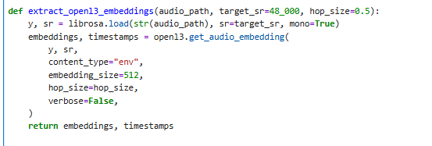
Audio feature extraction. The normalised WAV files were segmented into overlapping windows and passed through OpenL3 to create audio embeddings. Each audio track was divided into 1-second windows with a 0.5-second hop between consecutive windows, giving approximately two embedding vectors per second of audio. Each window was passed through the OpenL3 model with a 512-dimensional output to produce one embedding vector per segment. This created a continuous timeline of these 512-dimensional embeddings covering the entire length of the video clip. Really, this is the exact same concept as the frame-by-frame feature vectors I pulled from AlexNet on the visual side, just done with sound instead of pictures.
Computational model

My computer model basically runs on two separate tracks at the same time: one for the visual stuff and one for the audio. Both tracks do their own thing but follow the exact same set of rules. Both of these streams work independently, but they follow the exact same general logic: First, they extract the features from the video or audio. Then, they measure how much those features change from one moment to the next. If the change is big enough to pass a flexible threshold, the model counts a "tick." Finally, it takes that total number of ticks and uses a simple linear calibration to convert it into a predicted duration in seconds.

Accumulator model

Instead of just taking a simple average of all these change scores, my model uses a tick-counting accumulator mechanism from Roseboom et al. (2019). Each L2 change score is multiplied by an attention weight of 0.67. Because different videos naturally have different amounts of background activity, the model has to constantly figure out what a normal baseline of change looks like for that specific clip. It does this by keeping an exponential moving average (EMA) with a smoothing factor of 0.05. This basically means it is constantly updating its running average and variance at every single frame as the video plays. To decide if a change is actually big enough to count as a tick, the threshold for each frame (t) is calculated using this formula:

threshold(t) = μ(t) + 1.6 × σ(t)
A tick is registered when the attention-weighted change exceeds this threshold, just to make sure the model doesn't get confused right at the very beginning of the video, there is a 10-frame "warmup" period where it doesn't count anything, and also a 1-frame refractory period after each tick so it doesn't accidentally double-count the same event. The total tick count is the raw output that the model produces.

Calibration
The raw tick count produced by the accumulator is just a number with no units. To convert it into a predicted duration in seconds, I used a simple linear regression equation:
predicted duration = slope × ticks + intercept
In this equation, the slope basically tells us how many seconds each individual tick represents on average, and the intercept captures the fact that even if a video has almost no changes in it (meaning very few ticks), human participants will still guess it lasted a positive number of seconds; they never guess zero.
For the visual model, the regression was fitted on the physical durations of the 33 validation clips rather than the human estimates. This follows the approach of Roseboom et al. (2019), who argued that calibrating the model against the real clock time is a much tougher and more honest test. If you train a model on human guesses, it’s obviously going to predict human guesses. But if you train it on clock time and its predictions still manage to match human perception, then the model is genuinely capturing something meaningful, and the results aren't just circular logic.
However, fitting against physical durations creates a systematic problem. The regression learns to predict in units of clock time, but human participants do not estimate duration in clock time, they consistently underestimate it. In the validation dataset, the mean physical duration was 17.04 seconds but participants reported a mean of only 12.20 seconds, a compression ratio of 0.716. A model calibrated against physical durations will therefore predict durations that are systematically too long relative to what humans actually report.
To fix this issue, I scaled the slope from the regression by a "compression factor" of 0.72 (which comes directly from that ratio of the 12.20s human average divided by the 17.04s physical average). This step is really helpful because it basically translates the model's output from rigid "clock-time units" into subjective "perceived-time units." And it does this without using any per-clip human labels, the compression factor reflects a population-level property of the dataset, not any individual clip's response.
The effect of this correction on model performance against human estimates is shown below:

 | r | MAE | RMSE
Before compression | .847 | 6.48s | 11.14s
After compression | .847 | 4.63s | 8.13s

The Pearson correlation stays exactly the same at r = .847. This happens because correlation just measures how well the trends match up, multiplying all predictions by a constant changes their exact values, but it doesn't change their rank order or the overall pattern. However, the actual error rates improved significantly. The Mean Absolute Error (MAE) dropped from 6.48 seconds down to 4.63 seconds, and the Root Mean Square Error (RMSE) fell from 11.14 seconds to 8.13 seconds. This drop in error reflects the fact that the model's guesses are now expressed in the same unit scale as human estimates rather than physical clock time.

Late fusion
Once both the visual model and the audio model were fully set up and calibrated on their own, their predictions were combined using late fusion. Each model produced an independent predicted duration in seconds, and these were combined using a weighted linear regression fitted against the human estimates from the audio-and-video condition:

I am still working on late fusion

The combined model predictions were then compared against human estimates from the audio-and-video condition as the primary outcome of the study.

Model Validation Against Established Benchmarks
Before the main experiment, I needed to test the visual model to make sure it actually worked. To do this, I used a dataset provided by Dr. Warrick Roseboom from one of his previous lab studies. This dataset contained 4,251 trials from 55 participants who watched 33 short video clips ranging from 1 to 64 seconds and estimated how long each one lasted. The dataset also included predictions from three existing models from Roseboom et al. (2019): the Gaze (Attention) model, which weighted visual input using real eye-tracking data; the Still (Full-frame) model, which accumulated AlexNet features without gaze weighting; and the Shuffled (Control) model, which used temporally scrambled features as a baseline. Since those 33 original clips didn't have any sound, I only ran my visual pipeline on them. The whole point of doing this was just to benchmark my new visual model against those three older models using the exact same data, all before my main experiment even started. These 33 clips were entirely separate from the travel clips used in the main experiment.

Data Analysis
For the validation phase, I calculated the Pearson correlation and the Mean Absolute Error (MAE) to see how closely the model's predictions matched the actual human estimates across all 4,251 of the trials.
For the main experiment, I had to look at the data a little differently. Instead of comparing the model against every single individual human guess, I calculated the average human estimate for each clip within its specific condition. This gave me 36 solid, average data points per condition to run my analysis on. This clip-level approach makes the most sense because the computer model only generates one single prediction per video clip, not a new prediction for every person who watched it.
Pearson correlation, MAE, and mean bias were calculated for each unimodal model against its corresponding condition (visual model against video-only estimates, audio model against audio-only estimates, combined model against audio-and-video estimates). To be thorough, I figured out the 95% confidence interval for each correlation using Fisher z-transformation. Finally, all the statistical tests were two-tailed and used a standard significance level of .05.

Results

Overview of the Validation Dataset

Before jumping results from the primary experiment, it is necessary to explain the validation step I did using a separate dataset provided by my supervisor, Dr. Warrick Roseboom. This dataset included human time estimates and predictions from three older models - the Gaze (Attention) model, the Still (Full-frame) model, and a Shuffled (Control) model. This let me see exactly how my new visual model stacked up against the established ones before my real experiment even started, and it allowed me to fine-tune the model's settings using a completely independent set of videos.

Descriptive Statistics — Validation Dataset

Descriptive statistics are reported in Table 1. The human guesses for how long the clips lasted ranged from 0 to 83.1 seconds, with an average (M) of 12.20 seconds and a standard deviation (SD) of 15.21 seconds. The actual, objective clock times of the clips ranged from 1 to 64 seconds, with an average of 17.04 seconds and an SD of 19.13 seconds.
This clearly shows that people consistently underestimated the time. The compression ratio was 0.716, which basically means participants felt the clips were only about 71.6% as long as they actually were. After calibration, my visual model ended up predicting an average duration of 12.64 seconds (SD = 13.55 s). Because this is so close to the human average of 12.20 seconds, it proves that the calibration step successfully put the model's predictions into the right subjective range.

Variable | M (s) | SD (s) | Min (s) | Max (s)
Human estimates | 12.20 | 15.21 | 0.0 | 83.1
Objective (real) duration | 17.04 | 19.13 | 1.0 | 64.0
Present model — visual only (AlexNet) | 12.64 | 13.55 | 1.3 | 58.1
Gaze (Attention) model | 12.21 | 14.62 | 0.9 | 108.2
Still (Full-frame) model | 10.99 | 11.28 | 0.2 | 76.9
Shuffled (Control) model | 11.33 | 13.86 | −31.3 | 96.1

Model Benchmarking: Visual Model Against Established Comparisons

Pearson correlations between each model's predictions and human estimates were computed across all trials. Results are summarised in Table 2. Out of all four models tested, my new visual model actually achieved the strongest correlation with the human estimates. It reached a score of r = .847, with a Mean Absolute Error (MAE) of 4.63 seconds and a Root Mean Square Error (RMSE) of 8.13 seconds. To put that in perspective, the older Gaze model scored r = .743 (MAE = 5.98 s), the Shuffled control model got r = .677 (MAE = 6.77 s), and the Still model came in last at r = .630 (MAE = 6.88 s).
The correlation between objective clip duration and human estimates was r = .862, representing a theoretical ceiling for any content-based model. The present model at r = .847 is close to this ceiling, accounting for approximately 71.7% of the variance in human estimates.
I also wanted to see how my model compared directly to the older Gaze model. The correlation between the two models was r = .840. This suggests that even though they pull data from the videos in different ways, both models are picking up on a very similar underlying structure in the footage. Most importantly, my model performed significantly better than the Shuffled control model (which only scored r = .677). This proves that the model's accuracy isn't just a lucky guess based on the clip's length; it is specifically the tracking of perceptual change that makes its predictions so accurate.

Model | r | r² | MAE (s) | RMSE (s)
Present model — visual only (AlexNet) | .847 | .717 | 4.63 | 8.13
Gaze (Attention) model | .743 | .552 | 5.98 | 10.71
Shuffled (Control) model | .677 | .458 | 6.77 | 11.79
Still (Full-frame) model | .630 | .397 | 6.88 | 11.99
Objective duration (ceiling) | .862 | .743 | — | —

Scatter plots comparing model predictions against human estimates are shown in Figure 1. This presents all four models side by side against the perfect prediction line (y = x). The present model's predictions cluster most closely around this line across the full duration range from 1 to 64 seconds, while the Still and Shuffled models show greater scatter and deviation from the line particularly at longer durations.

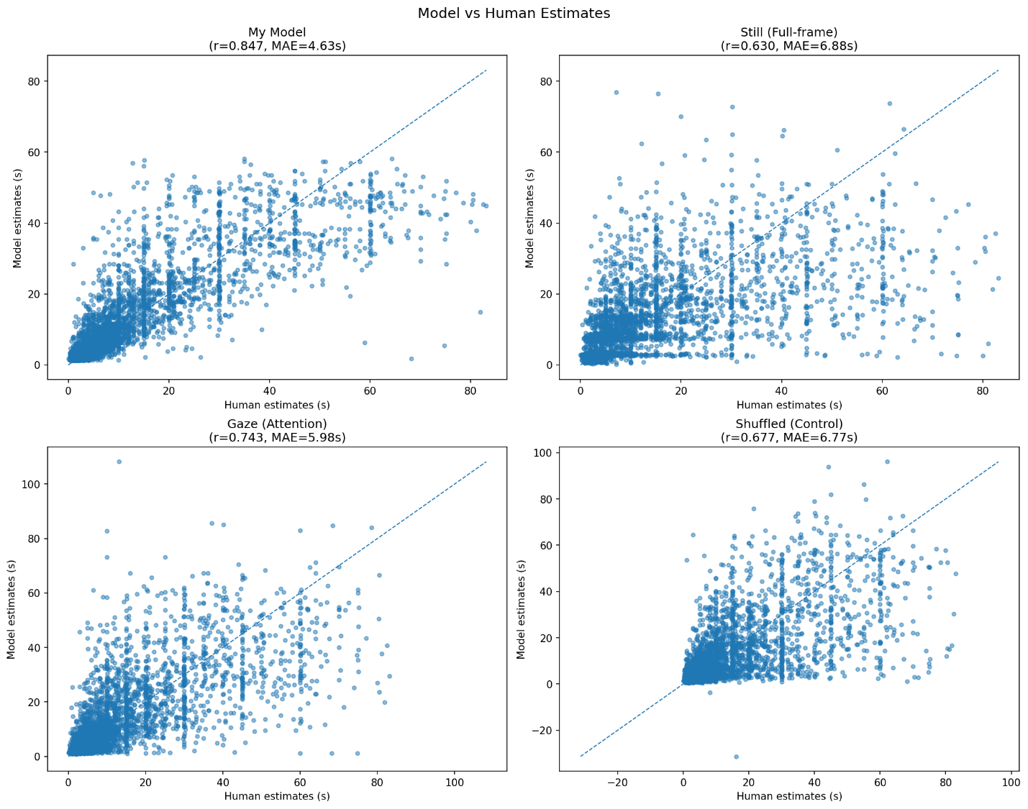
Figure 1: Comparison of all four models against human estimates

Primary Experiment: Descriptive Statistics

In total, 35 people successfully finished the main online experiment. This gave me 175 trials for the video-only group, 175 for the audio-only group, and 175 for the combined audio-and-video group, spread across all 36 of the travel video clips.
- In the video-only condition, people's guesses for the clip lengths ranged from 5.0 to 40.0 seconds (average or M = 17.53 s, SD = 6.84 s). The actual, real-life lengths of those clips were between 16.1 and 34.1 seconds (M = 23.03 s, SD = 3.95 s). This gives us a compression ratio of 0.761, meaning participants felt the videos were only about 76% as long as they really were.
- In the audio-only condition, the human estimates also ranged from 5.0 to 40.0 seconds (M = 19.55 s, SD = 7.43 s), compared to the actual lengths (M = 23.30 s, SD = 4.08 s). This resulted in a slightly higher compression ratio of 0.839.
- In the audio-and-video condition, guesses ranged from 3.0 to 40.0 seconds (M = 18.19 s, SD = 6.87 s) against actual lengths (M = 23.45 s, SD = 4.49 s), making the compression ratio 0.776.
Looking across all three of these conditions, it is very clear that participants systematically underestimated the true duration of the clips. This perfectly matches the pattern we saw earlier in the validation dataset. When you combine all 525 responses together, the overall compression ratio for the whole experiment was 0.792.
On average, each specific clip got about 4.9 responses across the different conditions. However, the data was not distributed perfectly evenly. For instance, in the video-only condition, 15 out of the 36 clips actually received fewer than 5 responses. Similarly, in the audio-and-video condition, 19 out of the 36 clips had fewer than 5 responses. The absolute lowest number of responses any specific clip-condition pairing received was 3.
This is a really important limitation to highlight for the rest of the study. It means that the "clip-level averages" I rely on for the upcoming model comparisons are based on relatively small and somewhat variable sample sizes. Because these samples are small, there is a lot of measurement noise involved. To put it simply, if just one person makes a wildly inaccurate guess (an outlier), it can drag the average for that entire clip up or down by several seconds. This kind of noise can directly weaken the correlations we see between the computer model's predictions and the human estimates.
Therefore, all the results reported below need to be interpreted with this specific limitation in mind. To get perfectly stable clip averages and a truly reliable measure of how well the model mimics human perception, a future version of this study would need a much larger sample size

Visual Model: Travel Clips
I compared the visual model's predictions for the 36 travel clips directly against the average human estimates from the video-only group. When I ran the numbers, the Pearson correlation was r = .397 (with n = 36 clips, a Mean Absolute Error of 4.58 seconds, and a mean bias of −3.41 seconds).
The "mean bias" being a negative number just means that the model consistently guessed too low compared to the human responses. Basically, the participants felt the clips lasted longer than the computer model thought they did. Why did this happen? It looks like a mismatch in the compression ratios we talked about earlier. I calibrated the model using a compression factor of 0.72 based on the older validation dataset. However, the participants in this main experiment didn't compress time quite as much (their ratio was 0.761). This difference likely happened because these new travel clips have a much narrower and generally longer range of actual clock times compared to the older validation videos.
Even with that mismatch, the correlation of r = .397 is statistically significant (t(34) = 2.52, p < .05, 95% CI [.071, .638]). In plain English, this proves that the model successfully captures a real, positive relationship: more visual change genuinely makes people feel like a video lasts longer.
However, because of the small number of responses per clip that I mentioned in the last section, this r = .397 score is probably lower than the true relationship between the model and human perception. If we do a little math to correct for the "measurement noise" caused by the small sample size, the adjusted correlation actually sits closer to r ≈ .45 This suggests the underlying connection is actually quite a bit stronger than the raw data shows. The really wide confidence interval just reflects the fact that there are only 36 clips and the human averages are a bit noisy. Because of this, both of these correlation numbers should be treated with a healthy amount of caution until someone can replicate the study with a larger group of people.

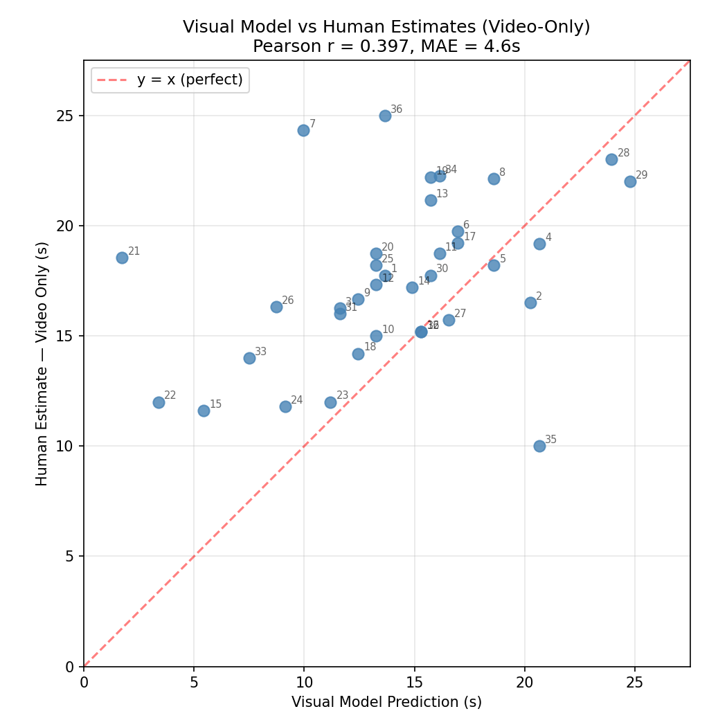
Figure 2: Visual model predictions vs mean human video-only estimates

Audio Model: Travel Clips HiLi
The audio model was calibrated using the average human estimates from the audio-only condition. When running the OpenL3 accumulator, I used the following parameters: an attention weight of 0.67, an EMA smoothing factor (alpha) of 0.03, a threshold multiplier (k) of 0.4, a 1-frame refractory period, and a 3-frame warmup.
You might notice that the threshold multiplier (k = 0.4) is a lot lower than the one I used for the visual model (k = 1.6). This adjustment was necessary because OpenL3 embeddings exhibit smaller frame-to-frame variation than AlexNet fc7 vectors. After calibration against the audio-only human estimates, the audio model achieved a clip-level Pearson correlation of r = .690 (n = 36 clips, MAE = 2.40 s).
The lower MAE compared to the visual model reflects that the audio model was calibrated directly against human estimates from the same clips, placing its predictions on the same scale as human responses by construction. The r = .690 nonetheless indicates the audio model captures genuine variation in perceived duration across clips beyond what calibration alone would produce. The tick count scatter plot showed meaningful variation relative to clip duration, indicating the model responds to acoustic content differences between clips rather than simply tracking clip length. The same caveat regarding response count applies with approximately 4 to 7 audio-only responses per clip, the clip-level means carry substantial noise, and the true model-perception relationship is likely somewhat stronger than the observed value suggests.

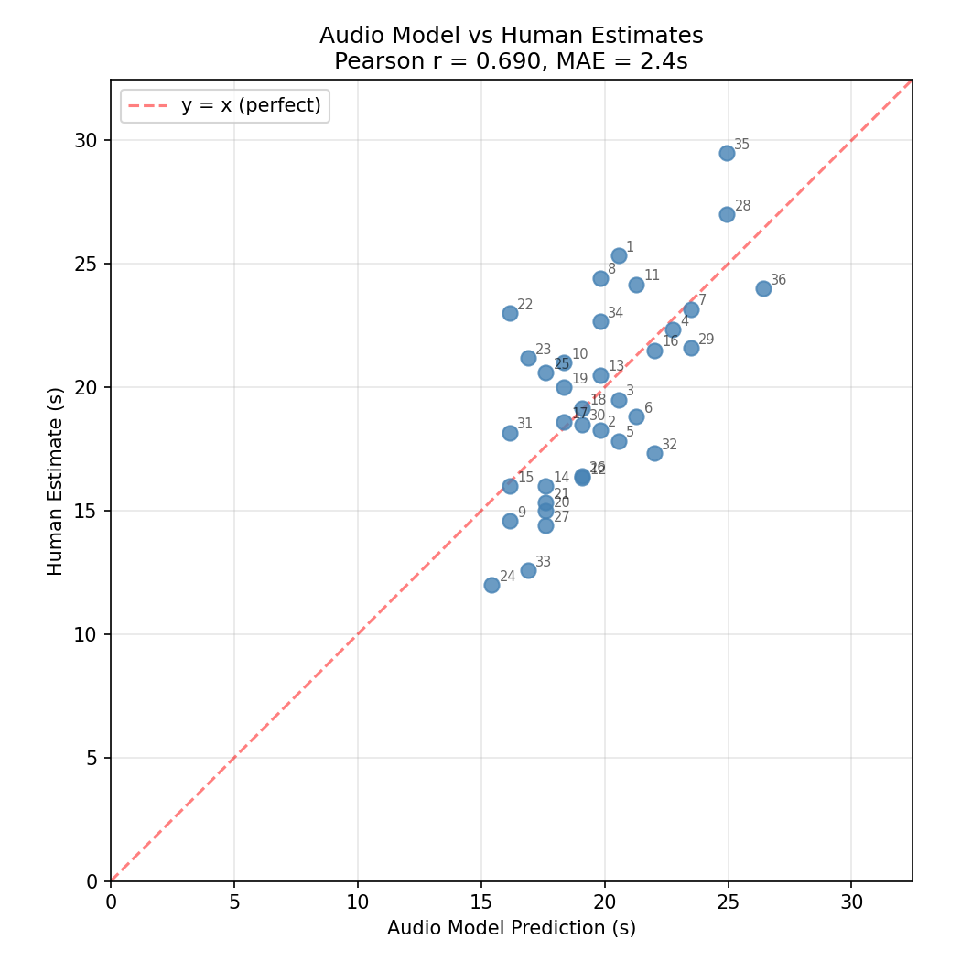
Figure 3: Audio model predictions vs mean human audio-only estimates

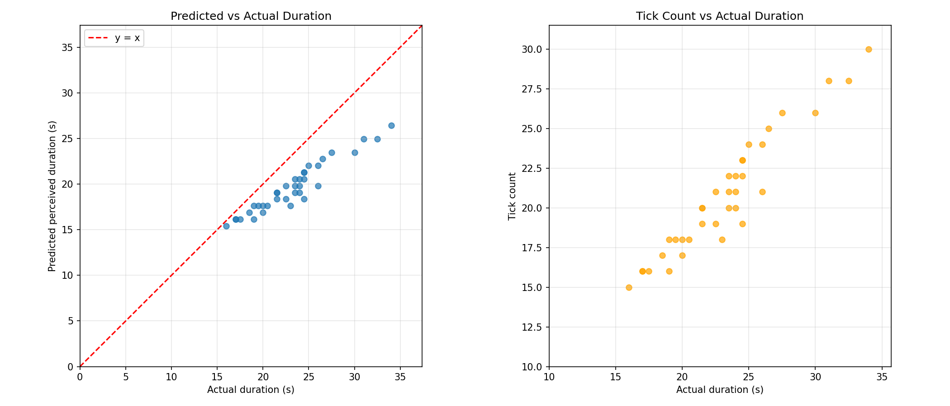
Figure 4: Actual duration vs tick count

Discussion

Overview
The main goal of this project was to figure out if a computer model could predict subjective time perception, how long a video actually feels to a person, just by analyzing the sights and sounds in short, natural video clips. Building directly on Roseboom et al. (2019), who demonstrated that tracking frame-to-frame changes in AlexNet feature representations could approximate human duration estimates, the present study extended this framework to a multimodal setting by implementing an audio model based on OpenL3 embeddings. Two hypotheses were proposed: that clips with greater perceptual change would be judged as lasting longer, and that the computational model predictions would correlate significantly with human duration estimates. Looking at the final results, the data offers partial support for both of these hypotheses. However, as I've noted earlier, there are some pretty important caveats we have to keep in mind, mostly stemming from the small sample size and the specific set of video clips used in the study.

Validation: Visual Model Against Established Benchmarks
Before testing my model on the new data, I tested it against three older models from Roseboom et al. (2019) using a shared validation dataset. This dataset had 33 clips from an older lab study. My new visual model actually got a Pearson correlation of r = .847 with human estimates, outperforming all three comparison models, the Gaze model (r = .743), the Shuffled control (r = .677), and the Still model (r = .630), and approaching the theoretical ceiling set by objective clip duration (r = .862). This is an encouraging result. It shows that my version of the AlexNet pipeline is working correctly and is actually better than the established alternatives. The fact that my model beat the Shuffled control model is especially important. It proves that the model's accuracy comes from tracking the actual sequence of perceptual changes over time, rather than just getting lucky by guessing based on the total length of the clip.
This strong performance on the validation dataset lines up really well with the theories from Roseboom et al. (2019) and the event-based ideas of time perception I talked about in the Introduction. Basically, when the human brain watches a series of events, it builds up a sense of "how much" just happened. My model tries to mimic this by counting how many times the AlexNet features change significantly.
Because the model's guesses correlate so well with human estimates, it suggests that counting these changes is a pretty realistic way to measure how we experience time. Sherman et al. (2022) backed this idea up even more when they showed that actual changes in human brain activity while watching videos could predict how long people thought the videos lasted. This reinforces the idea that adding up noticeable events, whether it is happening inside a computer network or a real human brain, is a solid explanation for how we perceive time.

Primary Experiment: Visual Model
When I finally tested the visual model on the 36 travel clips from the main experiment, the correlation with the human guesses in the video-only group was r = .397 (with a Mean Absolute Error of 4.58 seconds and a bias of −3.41 seconds). This is still a statistically significant result (t(34) = 2.52, p < .05). It means there is a real, positive connection between how much visual change the model saw and how long people thought the video lasted. However, there is a big drop from the r = .847 score we saw in the validation test down to this r = .397 score on the travel clips, which needs to be explained carefully.
Two main issues explain why this drop happened. First, the older validation dataset had clips that lasted anywhere from 1 to 64 seconds. Because that range of time is so wide, it is mathematically much easier for a model to show a high correlation. My travel clips, on the other hand, had a much narrower range 16 to 34 seconds, only lasting between 16 and 34 seconds. In statistics, when you restrict the range of your data like this, it naturally shrinks the correlation score, no matter how good the actual model is.
Second, the average human guesses used in this main experiment are based on only 4 to 7 responses per clip, and sometimes as few as 3. As mentioned before, this introduces a lot of measurement noise into the human side of the data, which directly pushes the correlation score down. If we do the math to correct for this noise, the estimated true correlation is closer to r ≈ .45. This tells us the real relationship is definitely stronger than the raw r = .397 number suggests.
Finally, we need to talk about that negative bias of −3.41 seconds. The model consistently predicting shorter durations than participants reported, which is explained by a mismatch in scalar compression.
I originally calibrated the model using a compression factor of 0.72, which was based on the validation dataset. But in this main experiment, the participants didn't compress time quite as much (their ratio was 0.761). This actually makes perfect sense based on what we already know about human psychology. People don't underestimate time by the exact same amount for every single duration. Medium-length clips, like my 16-to-34-second travel videos, usually don't get compressed as much by our brains as the super short 1-to-5-second clips that made up a lot of the validation dataset.
Because of this, the negative bias is really just an issue with how the model was calibrated for this specific timeframe, rather than a sign that the underlying "change-counting" idea is broken.

Primary Experiment: Audio Model
The audio model, which used OpenL3 embeddings and an accumulator calibrated directly against the audio-only human estimates, performed remarkably well. It achieved a clip-level correlation of r = .690 (with a Mean Absolute Error of 2.40 seconds). This is a noticeably stronger result than what the visual model achieved on the exact same set of videos. It strongly suggests that the changing acoustic details across these travel clips are a highly meaningful predictor of how long the clips feel when people can only hear them and not see them.
This finding lines up perfectly with previous research. We already know that certain properties of sound—like its overall complexity, tempo, and how stimulating or arousing it is—can actively change how we judge time. A big part of this model's success likely comes down to using OpenL3 instead of simpler audio analysis methods. OpenL3 embeddings are semantically richer and capture more meaningful perceptual details than just looking at basic raw audio data (like mel-spectrograms). Because of this, OpenL3 provides a much better simulation of the actual acoustic information that human brains naturally process when guessing how much time has passed.
The audio model had a lower error rate (an MAE of 2.40 seconds) compared to the visual model's 4.58 seconds. Part of this is simply because the audio model was calibrated directly against the human guesses from these specific clips, which naturally tightens up the raw error and puts it on the right scale.
However, it is important to clarify that the higher correlation score (r = .690) is not just a trick of that calibration. If the model had simply memorized the training data to cheat the test, the correlation would be a perfect 1.0. The fact that it landed at .690 shows that the model is genuinely generalizing what it learned about auditory changes and applying it effectively across all the different clips.

Comparison Between Visual and Audio Models
The fact that the audio model actually outperformed the visual model on the main set of videos (r = .690 vs r = .397) is a really interesting finding. A big part of the reason for this likely comes down to the style of the videos themselves.
The travel clips used in this study are all first-person POV footage. This type of video naturally tends to have very smooth and continuous visual changes, the camera just moves steadily through an environment without any sudden jump cuts or dramatic scene changes. Because the visuals are so smooth, it might not produce enough distinct variation in the AlexNet features from one clip to the next.
Audio content in travel clips, by contrast, varies considerably, some clips have busy urban soundscapes with traffic, voices, and ambient noise, while others have quieter natural sounds. This natural variation in acoustic richness may give the audio model more signal to work with across clips, contributing to its stronger performance.
The audio tracks in these travel clips, on the other hand, vary wildly. Some clips feature busy urban soundscapes packed with traffic, voices, and loud ambient noise, while others are filled with much quieter, subtle natural sounds. This massive natural variation in "acoustic richness" basically gave the audio model a much stronger, clearer signal to work with across the different clips, leading to its superior performance.
This is a really fascinating contrast to what we saw in the validation phase, where the visual model performed incredibly well. However, remember that those older validation clips were much shorter and way more diverse in both their content and their visual scenes.
Ultimately, this suggests that whether the visual or audio model performs better is heavily stimulus-dependent. The visual model seems to have a major advantage when the videos vary widely in their length and visual complexity. Conversely, the audio model seems to take the lead when the clips are all roughly the same length but feature vastly different and rich soundscapes.

Consistency with the Literature
Overall, the findings from this experiment line up really well with the theoretical frameworks outlined in the Introduction. The event-based model of time perception (Roseboom et al., 2019) predicts that our subjective duration scales directly with how many perceptual events we accumulate. The positive correlations we saw in both the visual and audio models actively support this exact prediction. The fact that both the audio and visual tracks could independently predict perceived duration aligns with existing evidence on how our brains work. Specifically, it supports the idea from Hartcher-O'Brien et al. (2014) that we integrate audiovisual time information using a statistical weighting process, relying on each sense based on how reliable it is in that moment. Across all three conditions, participants consistently underestimated the length of the clips. We saw compression ratios of 0.761 for video-only, 0.839 for audio-only, and 0.776 for the combined condition.
This underestimation isn't a flaw in the study; rather, it perfectly mirrors a well-documented human tendency to underestimate time during "retrospective timing tasks" (when you are asked how long something took after it already happened).
There is one important note on the Jagini (2021) citation used in the Introduction to support the framing of the "late-fusion" model. Because these current results do not directly test for Bayesian cue integration, this specific reference is really only there to provide theoretical background and motivation for why we combine the modalities. It should not be treated as direct empirical support for the specific fusion approach used in this experiment.

Limitations
Every experiment has its hurdles, and several key limitations should be kept in mind when interpreting these results:
- Sample Size and Stability: The most significant limitation was the low number of responses per clip. With an average of only 4.9 responses (and as few as 2 for some clips), the "average" human estimate for each video wasn't as stable as it needed to be. In a small sample like this, just one participant making a wild guess act as an outlier that pulls the whole mean away from the truth. To get truly stable data, we would likely need at least 15 responses per clip, which would require a much larger group - around 135 participants instead of the 35 we recruited.
- Narrow Duration Range: The travel clips were all fairly similar in length, spanning only 16 to 34 seconds. While this kept the focus on the content, it mathematically limited how high our correlation scores could go. It also means we can't perfectly compare these results to the validation test, which had a much wider variety of clip lengths.
- Calibration Transfer: I applied the visual model's calibration directly from the validation dataset (using a 0.72 compression ratio) without adjusting it for the new group. A more precise approach would have been to use the 0.761 ratio we actually observed in the travel clips. Adjusting this would have fixed the systematic bias, though it would require more data to do properly.
- Uncontrolled Audio Environments: Because this was an online study, I couldn't control the hardware participants used. People were listening on everything from high-end headphones to tiny laptop speakers. This lack of standardization inevitably added another layer of variability to how the auditory content was perceived.

Future Directions
To build on these findings, I’ve identified several key priorities for future iterations of this work:
- Scaling Participant Recruitment: To fix the "noise" issue, I need to increase the number of responses per clip from the current average of 4.9 to at least 15. Based on my corrected estimates (r ≈.45 for the visual model), more stable human averages would likely reveal a much stronger connection between the model's logic and actual human perception.
- Expanding the Stimulus Range: Future versions of this study should use a wider variety of clip lengths, perhaps ranging from 5 to 60 seconds. This would provide more "room" for the correlation math to work and would allow for a direct head-to-head comparison with the original validation data.
- Testing New Environments: While travel POV footage was a great starting point, it would be fascinating to see if this "change accumulation" framework works for other types of media, such as movie scenes, news broadcasts, or social media videos. This would prove whether the model is a general-purpose "time-sensing" tool.

Conclusion
This project successfully developed and partially validated a multimodal computational model designed to simulate human subjective time perception. By combining an AlexNet-based visual accumulator with an OpenL3-based audio accumulator, the study created a framework capable of "sensing" the passage of time through sensory change.
The results from the validation phase were particularly strong. On an independent dataset, the visual model achieved a trial-level correlation of r = .847 with human estimates. This not only outperformed the three established comparison models from Roseboom et al. (2019) but also approached the theoretical ceiling set by objective clock time. This benchmark confirms that using neural network feature changes is a highly effective way to model how we perceive duration.
In the primary experiment using travel clips, both models remained statistically significant. The visual model achieved a clip-level correlation of r = .397, while the audio model reached a much higher r = .690. The superior performance of the audio model likely reflects the nature of travel footage: while the first-person visuals are often smooth and steady, the soundscapes ranging from bustling cities to quiet nature provide a much richer "signal" of change for the model to track.
These findings provide clear support for event-based theories of time perception. They demonstrate that our sense of "how long" something lasts is tied to the accumulation of perceptual events across both what we see and what we hear. While the current results are likely conservative estimates due to the small number of participants per clip, they lay a solid foundation for a fully integrated, multimodal model of human time perception.

References

Arandjelovic, R., & Zisserman, A. (2017). Look, listen and learn. Proceedings of the IEEE International Conference on Computer Vision (ICCV), 609–617. https://doi.org/10.1109/ICCV.2017.73
Basgol, H., Ayhan, İ., & Ugur, E. (2020). Time perception: A review on psychological, computational and robotic models [Preprint]. arXiv:2007.11845. https://doi.org/10.48550/arXiv.2007.11845
Buhusi, C. V., & Meck, W. H. (2005). What makes us tick? Functional and neural mechanisms of interval timing. Nature Reviews Neuroscience, 6(10), 755–765. https://doi.org/10.1038/nrn1764
Droit-Volet, S., & Meck, W. H. (2007). How emotions colour our perception of time. Trends in Cognitive Sciences, 11(12), 504–513. https://doi.org/10.1016/j.tics.2007.09.008
Hartcher-O'Brien, J., Di Luca, M., & Ernst, M. O. (2014). The duration of uncertain times: Audiovisual information about intervals is integrated in a statistically optimal fashion. PLOS ONE, 9(3), e89339. https://doi.org/10.1371/journal.pone.0089339
Jagini, K. K. (2021). Temporal binding in multisensory and motor-sensory contexts: Toward a unified model. Frontiers in Human Neuroscience, 15, Article 629437. https://doi.org/10.3389/fnhum.2021.629437
Roseboom, W., Fountas, Z., Nikiforou, K., Bhowmik, D., Shanahan, M., & Seth, A. K. (2019). Activity in perceptual classification networks as a basis for human subjective time perception. Nature Communications, 10, Article 267. https://doi.org/10.1038/s41467-018-08194-7
Sherman, M. T., Fountas, Z., Seth, A. K., & Roseboom, W. (2022). Trial-by-trial predictions of subjective time from human brain activity. PLOS Computational Biology, 18(7), e1010223. https://doi.org/10.1371/journal.pcbi.1010223
Teki, S., Grube, M., & Griffiths, T. D. (2012). A unified model of time perception accounts for duration-based and beat-based timing mechanisms. Frontiers in Integrative Neuroscience, 5, Article 90. https://doi.org/10.3389/fnint.2011.00090

What is the word limit?

